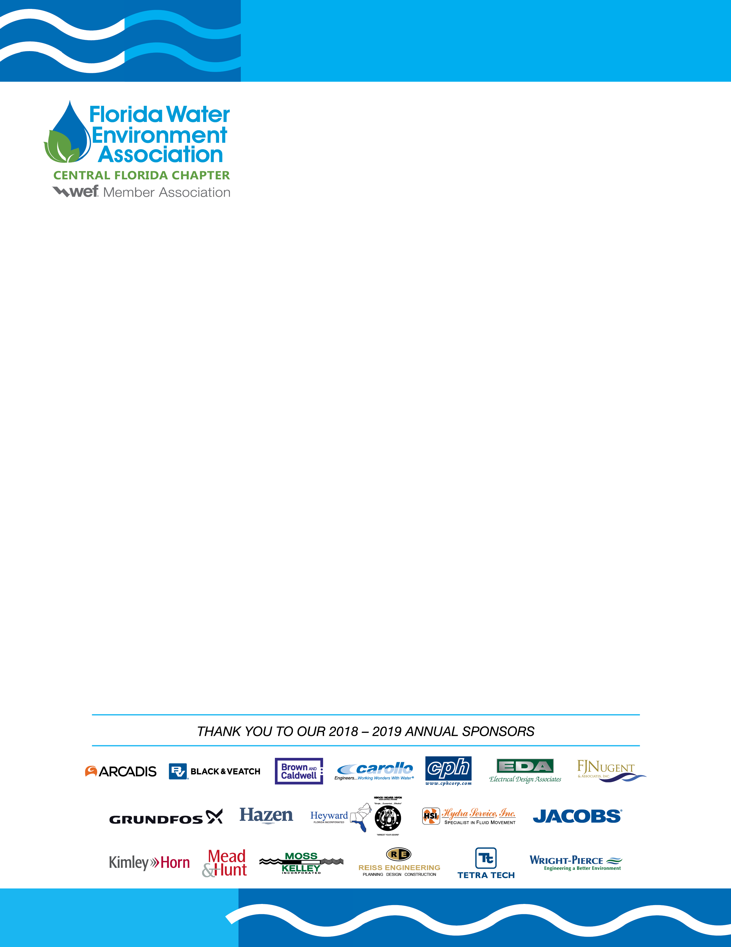

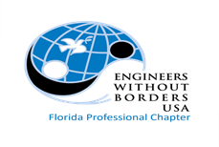

FWEA Central Florida Chapter &
EWB FL Professional Chapter
Technical Webinar

Thursday, January 13th, 2022
11:50 AM – 1:00 PM

Discussion Topic: Value in Trenchless Technologies
*Approved for 1 PDH
This presentation will provide an overview of utilizing trenchless technologies for pipeline rehabilitation projects. We will also discuss material selection for pipeline rehabilitation projects, as well as the limitations and benefits of using trenchless technologies.

Location: Virtual Platform: GoToWebinar Presenter: Todd Grafenauer,
Vice President/Educational Director
Murphy Pipeline Contractors
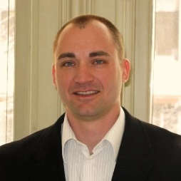
Cost: $10 for FWEA and EWB members
$15 for non-members
Each sustaining and virtual sponsor will receive
up to two (2) admission tickets.

Register: https://mms.fwea.org/members/evr/reg_event.php?orgcode=FWEA&evid=29825033
Online Registration closes January 12th, 2022

Contact: Sam Miller
Black & Veatch
MillerS@bv.com

Thank You to the 2021-2022 Virtual and Sustaining Sponsors of EWB-FL and FWEA

